Part 2:

1. Create a design document for a branded multipage website supporeted with the following:
2. Goal and Scope of the website (Design Document).
3. Who is the website for?

The website is primarily designed for gaming enthusiasts ranging from casual to hardcore gamers. The target audience includes individuals of various age groups, predominantly between the ages of 12 and 35, who share a passion for video games and gaming culture. This demographic is tech-savvy, frequently engages with online communities, and is always on the lookout for the latest releases, gaming hardware, and accessories.

The website will cater to their preferences by offering an extensive selection of games across various genres, gaming hardware, accessories, and merchandise. It will also provide a user-friendly interface, ensuring a smooth and engaging online shopping experience.

1. What do customers/ users expect to find or do there?

Extensive Product Catalog:

- Users expect to find a wide range of products related to gaming. This includes video games for various platforms (PC, consoles, mobile), gaming hardware (consoles, PCs, accessories like controllers, headsets)

Detailed Product Information:

For every product, users expect comprehensive details including price, High-quality images (trailers).

Users should be able to find the products by category.

Account Management:

The ability to create and manage a user account

1. Is this website’s primary aim to inform, to sell (ecommerce, anyone?), or to provide a service?

The primary aim of this game store website is to sell (eCommerce). It is designed as an online retail platform where customers can browse, select, and purchase a wide range of gaming-related products.

The core functionality of the website revolves around the online sale of video games, gaming hardware, accessories, and merchandise. It is structured to facilitate the entire sales process, from product discovery to checkout, while also providing comprehensive product information.

The scope of the game store website encompasses a comprehensive array of functionalities, content, and services tailored to meet the needs of the gaming community. The finished website will be utilized for the following purposes:

Online Retail of Gaming Products:

Serve as an all-encompassing eCommerce platform for the sale of video games across multiple platforms This includes video games for various platforms (PC, consoles, mobile), gaming hardware (consoles, PCs, accessories like controllers, headsets)

Provide a rich repository of product information, including detailed descriptions, high-quality images, gameplay videos, and trailers to assist users in making informed purchasing decisions.

Provide a secure, efficient, and user-friendly checkout process

Ensure the website is fully responsive and provides a seamless experience across various devices and screen sizes, catering to the needs of mobile users.

Implement SEO best practices and content marketing strategies to attract organic traffic, engage users with valuable content, and convert visitors into customers.

1. Write a full set of client and user requirements (Design Document)

Below is a set of client and user requirements that align with the goals and scope of the game store website. Each requirement is explained in detail, along with how it can be implemented on the website.

Requirement: Persistent Shopping Cart

Explanation:

Users expect their shopping cart contents to be retained even if they log out or accidentally close the browser. This requirement enhances the user experience by allowing them to resume shopping at a later time without losing their selected items.

Implementation:

Implement server-side session management to store cart data. When a user adds an item to the cart, it gets saved to the database linked to their user ID.

Upon login, fetch the user's cart data from the database and display it in the cart page.

Ensure that the cart contents persist and are retrievable in subsequent sessions until the purchase is completed or the items are manually removed.

Requirement: Dynamic Home Page with Slider

Explanation:

A dynamic home page with a slider provides an engaging visual experience, showcasing featured products, promotions, or announcements. It's a strategic way to capture user interest and guide them towards making a purchase.

Implementation:

Implement a carousel slider on the home page. Use high-quality images/graphics that represent the store's brand, special offers, or popular products.

Ensure the slider is responsive

Requirement: Detailed Product Pages with Categories

Explanation:

Users need access to detailed information about products to make informed decisions. Categorizing products improves discoverability and the overall shopping experience.

Implementation:

Create individual product tables that display detailed information, including product images, descriptions, specifications, price.

Implement a category system to organize products. Provide a category menu or filter options, allowing users to easily browse products within specific categories.

Include an "Add to Cart" button on each product box, enabling users to add the product to their shopping cart directly from the product details view.

1. A sitemap (Design Document).

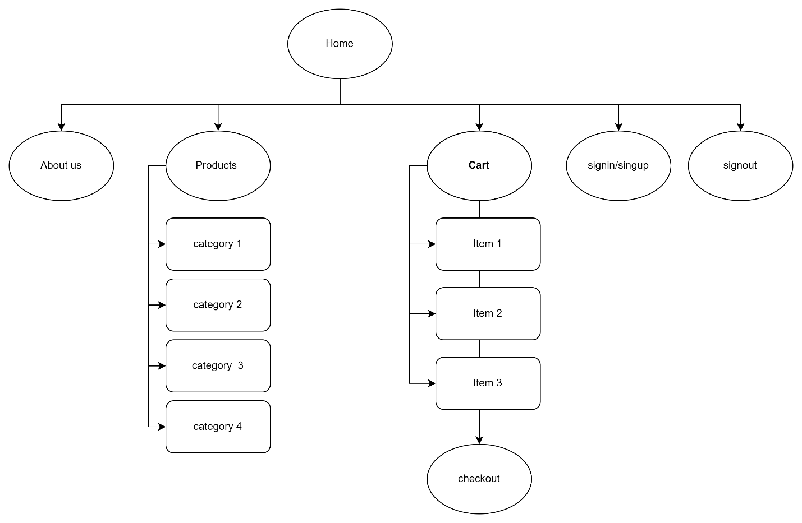

1. Medium-fidelity wireframes (Design Document).

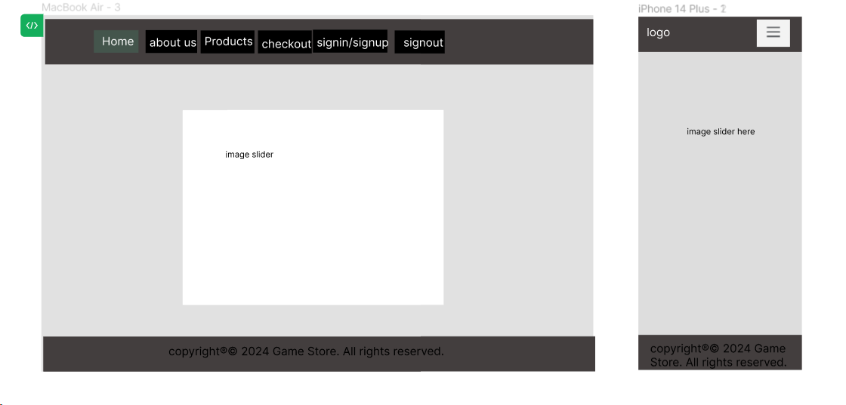

1. Explain the process you followed to register your domain name (Design Document).

Domain Name Registration

Selection of Domain Name: Initially, I brainstormed to come up with a unique and memorable domain name that reflects the essence of my website and is easy for users to recall.

Domain Name Search: I used the domain search tool provided by InfinityFree to check the availability of my preferred domain name. This step was crucial to ensure that the domain name was not already taken and aligned well with my brand identity.

Domain Registration: Once I found an available domain name, I proceeded with the registration process on InfinityFree. This involved filling out a registration form, providing necessary details like contact information, and agreeing to the terms of service.

Domain Configuration: After registration, I configured the domain settings, setting up DNS records to point to the correct web hosting server (in this case, the server provided by InfinityFree).

1. Explain the processes you followed to register the hosting service, and how did you manage uploading the files of the website to the final production environment (Design Document).

Hosting Service Registration and Website Deployment

Selection of Hosting Provider: I chose InfinityFree as my primary hosting provider for its reliability and the range of services it offers. Additionally, I used 000hostweb as a secondary option to ensure redundancy and better accessibility.

Signing Up for Hosting Service: I signed up for an account with 000webhost, choosing a hosting plan that suited my website’s requirements in terms of storage.

Setting Up the Hosting Environment: After signing up, I accessed the hosting control panel provided by 000webhost. Here, I configured the necessary settings, including database setup, email accounts, and other hosting-specific configurations.

Uploading Website Files:

I used the File Manager tool provided in the 000webhost control panel to upload the website files. This included HTML, CSS, JavaScript files, and other assets.

Alternatively, I also used FTP (File Transfer Protocol) clients like FileZilla for bulk file uploads, which offered a more streamlined and efficient way to transfer files to the hosting server.

Testing and Deployment:

Before making the website live, I conducted thorough testing to ensure all pages, links, and functionalities were working correctly.

After confirming that everything was functioning as expected, I finalized the deployment, making the website accessible to the public.

1. Use your design document with appropriate principles, standards and guidelines to produce a branded, multipage website supported with realistic content (**Website**).

(done)

1. Compare and contrast the multipage website created to the design document. (Report).

Visual Design and Branding:

The visual elements on the website, including color schemes, typography, and images, appear to adhere to the design document's guidelines. The gaming-centric theme is evident, which should resonate well with the target demographic of gamers aged 12 to 35.

Navigation and Layout:

The website's navigation structure aligns with the design document, featuring a clear and consistent menu that includes 'Home', 'About Us', 'Products', and 'Checkout'. The user interface promotes an intuitive browsing experience, crucial for e-commerce platforms.

Product Catalog and Information:

The product pages are well-designed, offering detailed information, including prices and high-quality images, which is essential for informed purchasing decisions. The category system for organizing products is in place, simplifying the product search process for users.

E-commerce Functionality:

Key e-commerce functionalities, such as a persistent shopping cart, dynamic home page with slider, and detailed product pages with an 'Add to Cart' button, are implemented successfully. These features are crucial for a seamless online shopping experience and are reflected well on the website.

User Experience (UX):

The website provides a smooth and engaging user experience as outlined in the design document. This is demonstrated by the functional shopping cart that retains items across sessions and a checkout process that is both secure and user-friendly.

Persistent Shopping Cart:

The shopping cart functionality maintains its state across user sessions, which is a significant requirement met by the website. This feature enhances user convenience by allowing them to resume shopping without losing their cart items.

Dynamic Home Page with Slider:

The presence of a slider feature indicates adherence to the design document. It should dynamically showcase featured products and promotions, capturing user interest.

Account Management:

The ability for users to create and manage their accounts is crucial for personalized experiences and repeat visits. This feature implemented effectively, as users can log in, sign out, their accounts.

Challenges and Recommendations:

Hosting and Domain Configuration: As mentioned, there have been issues with file uploads and hosting setup. It's recommended to troubleshoot these issues with the hosting provider or consider alternative hosting solutions if persistent problems occur.

SEO and Content: The website is currently lacking in SEO optimization and realistic content, which are vital for attracting and retaining users. It's recommended to focus on content development that aligns with SEO best practices, such as keyword optimization, meta tags, and descriptive URLs, to improve search engine visibility.

1. Critically evaluate the design and development process against your design document and analyse any technical challenges you faced during your development (Report).

Critical Evaluation of the Design and Development Process

The design and development process of a website is a crucial phase where the conceptualized ideas and requirements are brought to life. In evaluating the process against the design document for the Game Store website, we must consider how effectively the design intent was realized while also acknowledging the technical challenges encountered and how they were resolved.

Adherence to Design Document:

The development of the Game Store website largely adhered to the specifications laid out in the design document. Key features such as a persistent shopping cart, dynamic home page slider, detailed product pages, and account management functionality were implemented successfully. The visual design matched the brand identity, and the navigation structure was consistent with the sitemap provided.

Technical Challenges:

Shopping Cart Functionality:

Issue: Initially, the cart did not update or remove items correctly, nor did it reflect changes in the database.

Resolution: The issues were addressed by debugging and refining the back-end code that manages cart operations and database interactions, ensuring that cart actions performed by users were accurately captured and stored.

Session Management:

Issue: User sessions were not being managed correctly, which is a critical aspect of user experience and security.

Resolution: The session management logic was overhauled to ensure that user states were maintained consistently across the website, with proper session initiation and termination.

User Account Management:

Issue: There were problems with user account creation, management, and authentication.

Resolution: The user account management system was thoroughly tested and refined to fix bugs and streamline the user registration and login processes.

Representation Issues:

Issue: There were unspecified issues with the representation of data or UI elements on the website.

Resolution: The front-end code was reviewed and adjusted to correct any inconsistencies with the design document, ensuring a cohesive and accurate representation of information.

Total Price Calculation:

Issue: The total price in the cart was being calculated incorrectly.

Resolution: The price calculation algorithm was corrected to accurately total the prices, taking into account quantities.

Database Reflection of Cart Actions:

Issue: Actions like adding to the cart were not being reflected in the database.

Resolution: The integration between the front-end actions and the back-end database was debugged and fixed to ensure that all cart actions were properly recorded in the database.

Analysis:

The development process demonstrated a strong capacity for problem-solving and technical proficiency in addressing and resolving the issues that arose.

Effective testing procedures were crucial in identifying the issues early in the development process, allowing for timely resolutions.

The challenges highlighted the need for rigorous testing, particularly in areas involving user interaction and data management.

Future recommendations include:

Search Functionality:

Recommendation: Implement a robust search feature with auto-complete suggestions to help users find products more quickly and efficiently.

Justification: A search function is essential for allowing users to navigate large inventories, improving the overall user experience and potentially increasing sales.

Advanced Product Filtering:

Recommendation: Develop advanced filtering options that allow users to narrow down product selections based on various attributes like price, brand, release date, and user ratings.

Justification: Advanced filters enhance the shopping experience by making it easier for users to find products that meet their specific needs and preferences.

Product Comparison Tool:

Recommendation: Introduce a product comparison tool that allows users to compare features and prices of different products side by side.

Justification: A comparison tool helps users make informed decisions by clearly outlining the differences and similarities between products.

Customer Reviews and Ratings:

Recommendation: Add a customer review and rating system for products to provide social proof and assist users in the decision-making process.

Justification: Reviews and ratings can influence purchasing decisions and provide valuable feedback to both potential customers and the business.

Live Chat Support:

Recommendation: Offer live chat support to assist users with any inquiries or issues they may encounter in real-time.

Justification: Live chat can improve customer service by providing immediate assistance, which can also help in reducing cart abandonment rates.

Mobile App Development:

Recommendation: Consider developing a mobile application for the platform to offer an alternative access point for users who prefer apps over web browsers.

Justification: A mobile app can provide a more streamlined experience for users and can leverage device capabilities for enhanced functionality.

Social Media Integration:

Recommendation: Integrate social media sharing options to allow users to share products with their networks easily.

Justification: Social media integration can help increase brand visibility and organic reach through user-generated content.

Wishlist / Favorites Feature:

Recommendation: Incorporate a wishlist or favorites system where users can save products they are interested in for future reference.

Justification: This feature encourages users to return to the site and can serve as a reminder for potential purchases.

Subscription Services and Memberships:

Recommendation: Offer subscription services or memberships that provide benefits such as discounts, free shipping, or early access to new releases.

Justification: Subscriptions and memberships can enhance customer loyalty and create a recurring revenue stream.

Continuous User Experience (UX) Improvement:

Recommendation: Regularly conduct user experience research and usability testing to gather feedback and continuously improve the interface and workflows.

Justification: As user expectations evolve, staying attuned to their needs can drive engagement and conversion rates.

Advanced Analytics and User Tracking:

Recommendation: Integrate advanced analytics tools to track user behavior, engagement, and conversion metrics more effectively.

Justification: In-depth analytics can provide insights into user behavior patterns, enabling data-driven decisions to optimize the website.

Scalable Architecture:

Recommendation: Ensure that the website's architecture is scalable, using cloud services and modern architectural patterns like microservices where applicable.

Justification: Scalability is key to handling growth in user traffic and transactions without compromising on performance.

Comprehensive Security Framework:

Recommendation: Build a comprehensive security framework that includes regular updates, patches, and adherence to best security practices.

Justification: Ongoing vigilance in security is necessary to protect against emerging threats and vulnerabilities.